**Job Folder Procedures for Documentation and Scanning**

**Step 1: Cleaning Scanner**

1. Ensure the EPSON scanner is powered off.
2. Using a clean cloth, wipe down the exterior of the scanner removing all dust particles from the outside of the scanner.
3. Open the scanner.
4. Using a flashlight, inspect the glass surface for dust and debris.
5. Douse a clean cloth with two sprays of lens cleaner away from the scanner. *Do not spray the scanner directly.*
6. Wipe the scanners glass surface with the doused cloth, removing all dust and debris.
7. If a film or any residue is left on the glass surface by the lens cleaner, use a dry cloth to wipe it off.

**Step 2: Scanner Startup**

1. Power on the Epson scanner with the button on the lower left of the front of the scanner.
2. On the desktop double-click the EPSON icon to launch the scanning software.

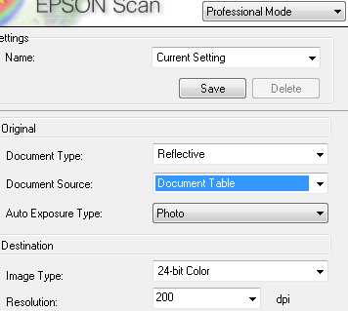

1. Ensure the scanning settings are as follows:
   1. Mode: **Professional Mode**
   2. Document Type: **Reflective**
   3. Auto Exposure Type: **Photo**
   4. Image Type: **24-bit color**
   5. Resolution: **200 dpi**

**Step 3: Preparing Document for Scanning**

1. Take the first envelope behind the divider in the crate and place it on the desk.
2. Open the envelope and carefully remove its contents onto the desk, ensuring that the order of the documents is preserved.
3. The first document of every envelope will be a scanned document; this document is a copy of the original job folder.
4. Using the brush, lightly brush the documents, removing dust and debris. Always brush towards the edge of the desk so that dust and debris will fall off the desk. Workspace is confined and brushing back and forth will only push dust into the air to settle back down onto your documents.
5. Once the document has been cleaned, ensure Step 1 has been completed.

**Step 4: Document Titling Procedure**

1. The base titling format for job folder covers is as follows:

*<envelope name><->(envelope)_<back>*

* 1. *<envelope name>* refers to the identifying name on the outside of the manila folder the documents are stored in.
  2. *<->* a dash is **only** placed when there is not an existing dash in the envelope name.
  3. *(envelope)* identifies the scanned document as the job folder cover in our database and must be present, **including** parenthesis.
  4. *<back>* identifies the scanned document as a back in our database and must be present when appropriate, **excluding** brackets.
     1. When a back is present, the document name must be changed manually because the software does not allow alpha characters after the numeric number is assigned.
  5. The scanning software will always assign a numeric value to scanned documents, you must manually remove the number at the end of the scanned job folder document and reset the counter to 001.

1. The base titling format for job folder documents is as follows:

*<envelope name><->_<document number>.<subfolder document number>.<sub-subfolder document number>_<back>*

* 1. *<envelope name>* refers to the identifying name on the outside of the manila folder the documents are stored in.
  2. *<->* a dash is **only** placed when there is not an existing dash in the envelope name.
  3. *<document number>* is an assigned number that identifies the documents place in the envelope starting with 001 as the first document following the copied job folder at the top of the document.
  4. *<subfolder document number>* is **only** assigned when a group of documents are bound together.
     1. Methods of binding can include; staple, paperclip, envelope, paper binding.
     2. The binding object will only be scanned if it contains information. (e.g. envelopes with addresses, names, or calculations or paper bindings with titles or reference numbers.)
     3. Scanning software does not support this titling format, document names must be formatted manually.
  5. *<sub-subfolder document number>* is **only** assigned when a group of documents are bound within an already bound group of documents. Binding methods are the same as subfolder documents.
     1. Scanning software does not support this titling format, document names must be formatted manually.
  6. *<back>* identifies the scanned document as a back in our database and must be present when appropriate, **excluding** brackets.
     1. When a back is present, the document name must be changed manually because the software does not allow alpha characters after the numeric number is assigned.

1. If a document does not have a value for a field then it will not be present in the document name. For instance, if a document is the 5th document of folder 16-H it will be titled *16-H_005*, but if it was the 10th subfolder document of the 5th document in folder 16-H it would be titled *16-H_005.10*
2. All documents will have at minimum an envelope name and document number.

**Step 5: Scanning Document**

1. Place the cleaned document face-down on the scanner.
2. Close the scanner lid.
3. On the scanning software, click the scan button.
4. In the following window prompt chose these settings:
   1. Location: Select **Other**, click **Browse** and navigate to the index folder.
      1. Note: We want to have all the documents and maps from one folder to be in the same folder in the computer.
   2. File Name: input the name of file with correct formatting from Step 4.
   3. Image Format Type: **TIFF**

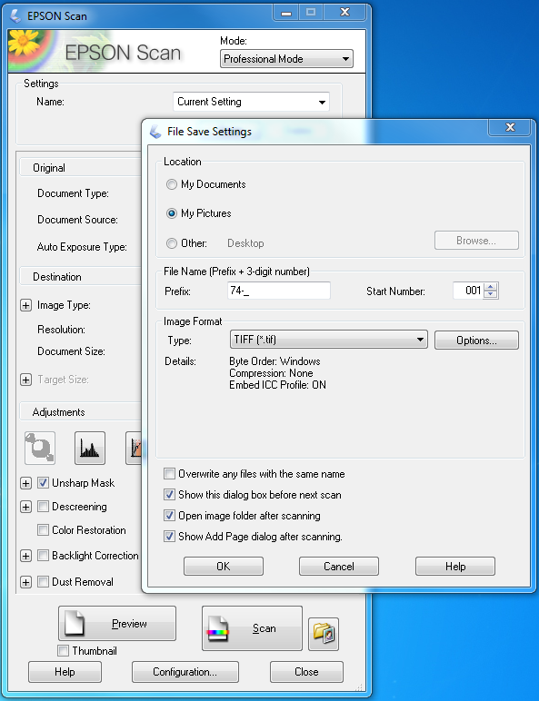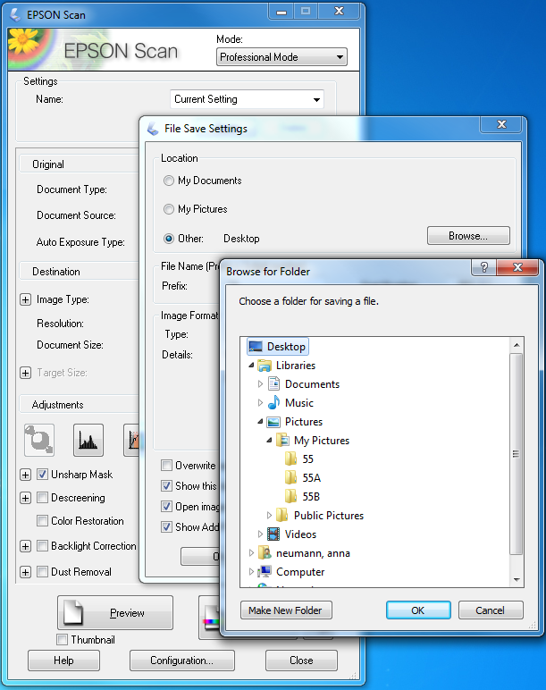

**Step 6: Editing Documents**

1. Scanning software does not allow cropping so job folder documents will need to be edited using the Auto-Cropping application and/or Microsoft Office.
   1. Auto-Cropping Application:
      1. Make sure all image files have .tiff extension and the image name doesn’t have space.
      2. Open Auto-cropping application, set safe-space to 25 pixels (default).

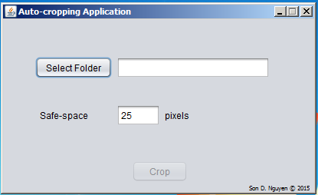

* + 1. Choose “Select Folder” and select one folder that have uncropped maps. And click “Open”.
    2. Click “Crop” and the application will display the message “Cropping Completed!” after a few minutes.

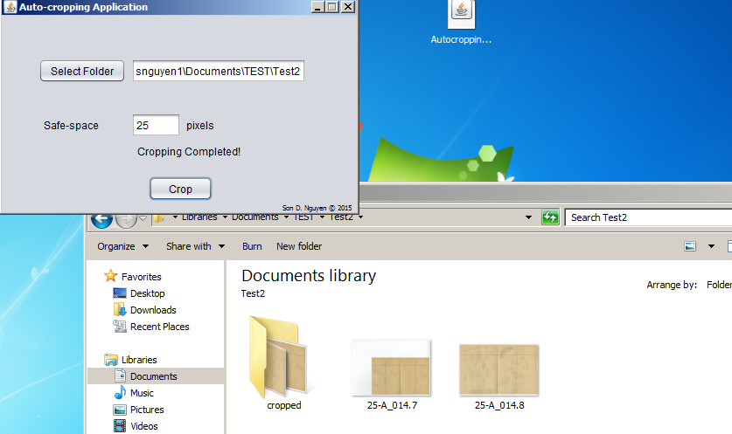

* + 1. All the cropped maps are stored in the “cropped” folder inside the selected folder.
    2. Go to “cropped” folder and check whether the maps are cropped correctly or not.
    3. If a map was not cropped correctly, delete the cropped image and crop the image manually with Microsoft Office Picture Manager. The cropped image will always be saved in the “cropped” folder.
    4. Note:
       - ImageMagick software and Java Runtime Environment (JRE) are needed to run this application.
       - Autocropping, ImageMagick & JRE can be downloaded from “Utilities” on the Job Folder homepage.
  1. Microsoft Office Procedure:
     1. Open document with Microsoft Office.
     2. Click on edit picture (top toolbar)
     3. Select crop (right toolbar)
     4. Crop image leaving small margin around image.
     5. Click ‘OK’
     6. Rotate the image if needed
     7. Zoom in to check the details
     8. Save cropped image

**Step 7: Returning Documents**

1. When finished with all the documents, turn them over so that they are in the original order, and carefully place them back into the job envelope.
   1. Avoid disheveled piles when returning documents. If the stack is not neat edges can get caught on the manila envelope and potentially damage the documents.
   2. Separate the documents into smaller stacks if necessary. Ensure original order is preserved.
2. After scanning is complete for the day, be sure to copy all scanned documents onto the Job Folder external hard drive.

**Notes**

* When a larger map or any document that doesn’t fit the small scanner is encountered, scan it in the large scanner then move back to the computer connected to the small scanner and put it on the document stack, preserving original order.
* If the maps or documents are in poor shape, Audrey will not give them to us. Instead, there will be a note inside the envelope with the information about the maps or other documents that belong to this envelope. Please DO scan this note as if it were a document!
* Be very careful with tracing and other field notes paper. Brush them carefully. We might need to use a flat spatula and a piece of rigid paper or plastic to move the maps or documents from the desk to the scanner and back.
* After every 10 scans, inspect and clean the scanner glass following the procedures outlined in step 1.
* Do not use gloves with any job folder documents or maps.
* Stop and call the Library if there is a special case, complication, or question on how to handle, scan, or catalog a map or document.